**Spiral Tubes (set 3)**

<https://www.activitiestoshare.co.uk/spiral-tubes-set-3>

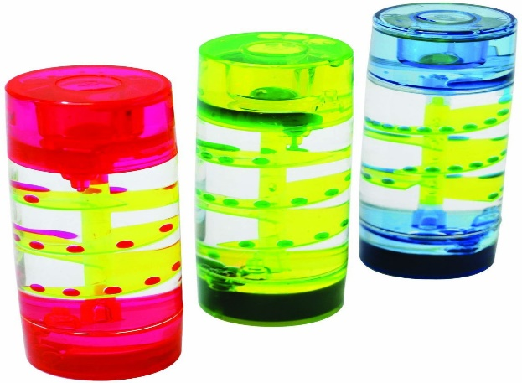

**Cost-£27.36 https: /www.activitiestoshare.co.uk/chunky-noughts-and-crosses**

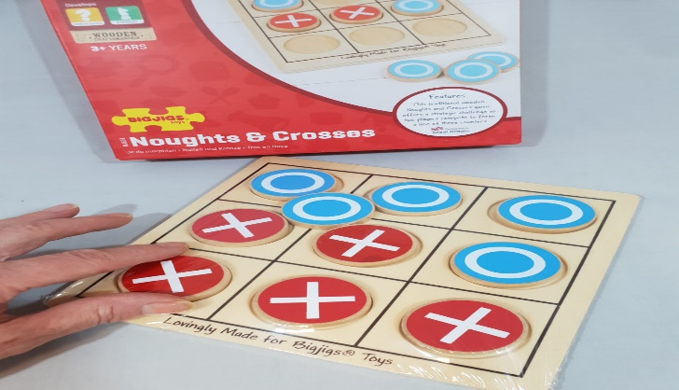

**Dominos (Activities to Share) https://www.activitiestoshare.co.uk/large-print-dominoes**

**Cost-£22.61**

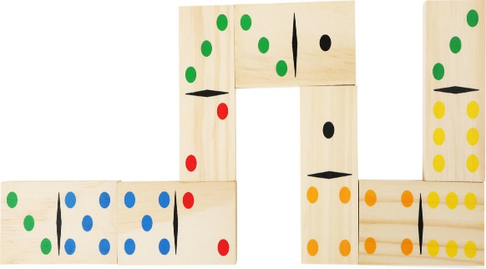

[Activities for Care Homes |Search (activitiestoshare.co.uk)](https://www.activitiestoshare.co.uk/filterSearch?q=nuts+and+bolts)

**Nuts and Bolts – Cost £14.99**

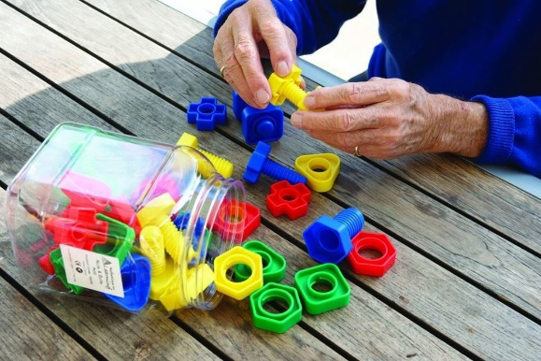

**Everyday Living conversation pack (Age concern) £15.95**



Memory Joggers -£34.99

[Activities for Care Homes |Entertainers Conversation Cards a great group activity : Activities To Share](https://www.activitiestoshare.co.uk/memory-joggers-entertainers)



**Alzheimer’s Society shop**

**£19.99**

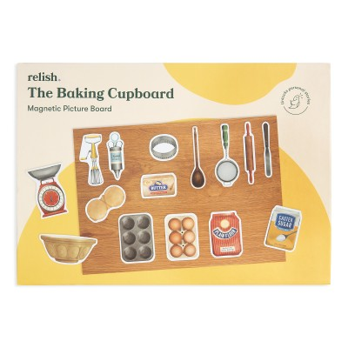

**£19.99**

